How to guide reddit post

As a part of the creation of my enable3d blog I created a reddit post to promote it on the r/three.js subreddit as I believed this was a suitable place for it to be posted as it is likely people that are interested in this library would be on there, When creating this post I took into consideration other exposure posts to guides like my own on the sub reddit and on other similar sub reddits like r/javascript like: <https://www.reddit.com/r/threejs/comments/my6s4c/a_helpful_class_i_add_to_threejs_so_i_can_inline/>. And <https://www.reddit.com/r/javascript/comments/mxhhqi/i_created_a_free_open_source_landing_page/>.

Some of the things I noticed about these posts are they keep things short and simple, So this is what I did I made a short title and poster it linking to my notion web page to three.js forum giving it the Tutorial flair.

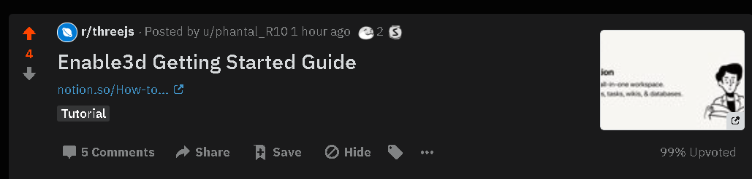

And in the comments, I did a short explanation of the guide itself.

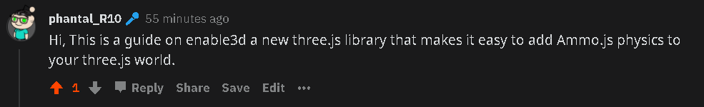

This post after an hour got 4 upvotes including my own and a few comments.



This is the link to the post: https://www.reddit.com/r/threejs/comments/mygktp/enable3d_getting_started_guide/